

**THE S'**

**ACADEMY OF TECHNOLOGY, KOLKATA**

|  |  |  |  |
| --- | --- | --- | --- |
| **NAME** | **CT NO.** | **EMAIL ID** | **ROLE** |
| Shashi Prakash Shah | CT20162051015 | shahshashi97@ymail.com | Team Leader |
| Shubhabrata Ghosh | CT 20162081734 | shubhabrata.ghosh@hotmail.com | Team Member |

**EDGE COMPUTING**

**SOLUTION**

**Video Presentation Link:**

**Github link:**

1. **Introduction/ Understanding the Problem statement:**

Kirana is a retail store looking for more digitalized way of expanding their business. They want to use a more systematic way of checkout system and reduce their human work force at billing counters. Retail store is a place where people get their daily necessities ranging from food products, clothing, electronic appliances etc. The basic idea to manage purchases of merchandize by customers and keep track of inventory used in the Malls and Shopping centres is to detect products using barcodes. However, the barcode system is no longer the best way to business operation. Customers are tired of waiting in long, slowly moving checkout line in departmental stores, especially, in holiday. Here is a system based on edge computing that allows automatic detection of product using camera with these main benefits: It creates a better shopping experience for the customers by saving their time as well as it increases the customer handling capacity of the store. It reduces the man power required at shopping mall, as the checking out process at the check-out counters is minimized.

The proposed solution is based on the following requirements:

* Creation of a web application named “*Kirana Product Billing*”
* Automatic detection of product from images.
* Automatic generation of bill of material based on product detected.
* Machine learning Model to be deployed on cloud.

**Details of technology Used:**

For the implementation of the solution for the given problem following technologies is applied:

* Web Server: Apache version – 2.4.18-2ubuntu3.13,
* Machine learning model: Tflearn based Convolution Neural Network,
* Python script: Python version – 3.7.3,
* Bootstrap & JQuery.

**Required Software /Hardware:**

* Hardware:

Edge Server:

* + i5 3rd Generation Processor
  + 4GB RAM
  + 500Gb Hard Disk
  + Monitor.
* SOFTWARE:
  + Linux(Ubuntu Xenial Xerus )
  + Web Server(Apache2)
  + A Web Browser.

**Achieved cost saving:**

**Cloud environment:**

Google Cloud is a platform that provides APIs for all its services and provide virtual machine which removes the requirement of many compute intensive devices for training the machine learning.

**Reduced workforce**:

With the implementation of this solution there will be reduced human workforce at the billing counter which will reduce monthly cost of the shop.

**Architecture:**

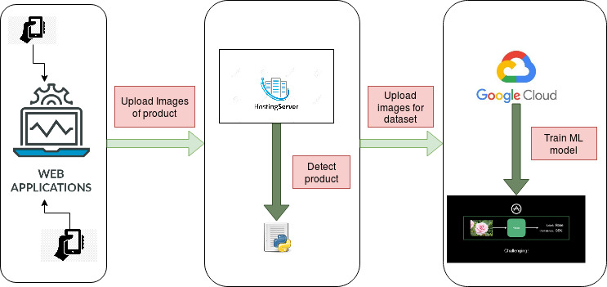

Figure 1:High level architecture

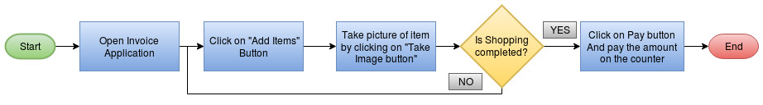

**Solution Brief Description:**

Figure 2 Flowchart of the application

* **Edge Server:** On the premises of the shop will reside an edge server which can be a computer with low specifications or a raspberry pi. The edge server is used to detect the product from the image uploaded by the user to add the desired product in the invoice automatically.
* **Cloud server:** In this solution we have proposed to use Google Cloud platform to train the ML models on the pre designed dataset composed of different products.
* **Web Application:** The process of billing is done through the web application named “Kirana Product Billing”. This web application will reside on the edge server installed at the premises of the store, and users will use this web application to generate automatic billing. This application is created using Hypertext Markup Language (HTML), Cascading Style Sheet (CSS), JavaScript and python script.

**Scope of Automation:**

**Better dataset:** Labelling the images uploaded by the user with correct label considering the products they add in the invoice will help in the automatic generation of large dataset which can be used to make better prediction in the future.

**Automatic Training:** On the weekend or holidays, the dataset generated by users can be uploaded to the cloud and the training on that dataset is run as a scheduled task for better training of the Machine Learning model.

**Conclusion:**

The Kirana Product Billing application which is created using Front-end development tools and python shows the capabilities of edge computing by predicting the product and creating the invoice at the server installed in the premises of the store rather than at the cloud. This solution will reduce the waiting time of the customers at the billing counter significantly and will help the store owner to handle large volume of customers efficiently. As the application will run on the edge server and on the devices of the customer, it will be less dependent on the internet and will work efficiently in remote locations with intermittent connectivity.